Stretching & Shrinking Review Test

- Do you have enough information to determine whether the two polygons below are similar? If not, what additional information do you need?
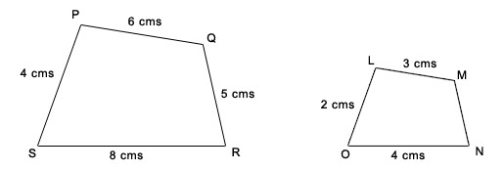

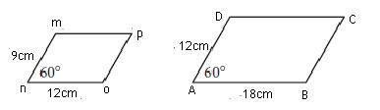
- Parallelograms ABCD and mnop are similar. (delete the 18cm and solve for AB. 18 is WRONG)

- What is the length of side AB? ______________ What is the measure of $∠n?$ ______________

- What is the ratio of the lengths of two adjacent sides in parallelogram mnop?

$$\frac{no}{mn}=$$

- What is the ratio of the length of two adjacent sides in parallelogram ABCD?

$$\frac{AB}{AD}=$$

- What is the ratio of a pair of corresponding sides in the two parallelograms?

$$\frac{AD}{mn}=$$

- What does the ratio above tell you about the two parallelograms?

- If two figures are similar, which of the following may be different. Circle all that apply.

A. number of sides B. size of angles C. shape D. area

E. lengths of corresponding sides F. Nothing

- Which of the following rectangles shown below is similar to a 15-by-30 rectangle? Circle your answer.
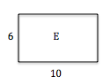
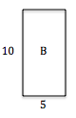
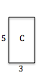
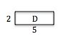
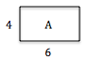

- Describe in words what would happen to a figure if you transformed (x, y) using the rule given below. Use words such as stretch/shrink, shift left/right/up/down, base, height, etc.

(3x, y + 5)

- Complete the table below given Rectangle A with dimensions 1cm by 6cm.
Rectangle Name | Scale Factor | Short Side | Long Side | Perimeter | Area
A | 1 | 1 | 6
B | 3
C | 10
D | ½

- Determine the height of the flagpole. Be sure to show your work, label and circle your answer.

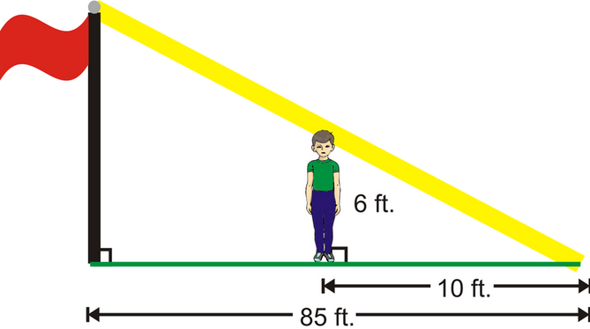

- Which of the rules below was used to make the image? Circle your answer.

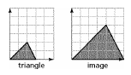
A) (2x, 2y)

B) (x, 2y)

C) (2x, y)

D) (2x, 4y)

E) (4x, 2y)

- A rectangle has dimensions of 4 and 10. Another rectangle was drawn from it, using a scale factor of 2.5.

- The perimeter of the larger rectangle is _______________ times the perimeter of the smaller rectangle.

- The area of the larger rectangle is _______________ times the area of the smaller rectangle.

- The triangles below are similar. Find the missing measurement of x ONLY. Do NOT solve for y. Be sure to show your work! Place your answer on the space provided.
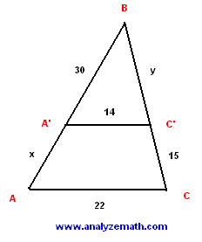

______________________

- After traveling 70 meters in its dive, a submarine is at a depth of 25 meters. What will be the submarine’s depth if it continues to give for another 110 meters? Show your work and place your answer on the space provided below.




